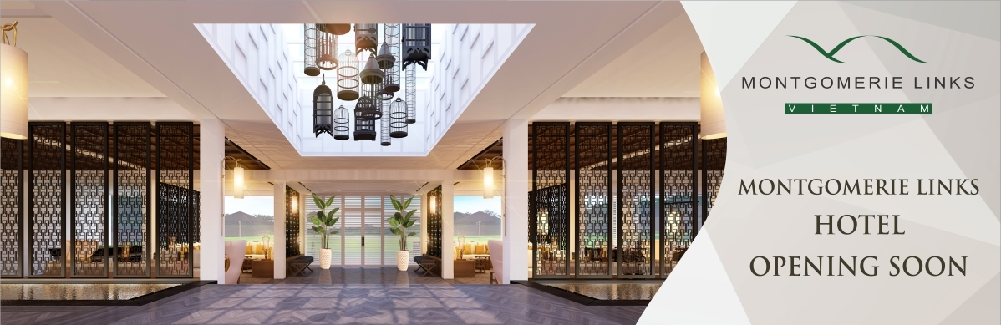
MONTGOMERIE LINKS VIETNAM – Dien Ngoc Ward, Dien Ban Town, Quang Nam Province
Tel: (84-510)3 941 942, Website: www. montgomerielinks.com; Email: career@montgomerielinks.com
FACEBOOK FANPAGE: Montgomerie Links Vietnam – Tuyển Dụng

We’re hiring – Tuyển Dụng
Sân gôn Montgomerie Links Vietnam với tiêu chuẩn quốc tế 5 sao tọa lạc trên bờ biển đẹp của Miền duyên hải – Miền Trung, được bình chọn là “1 trong 10 sân gôn tốt nhất Châu Á” (2012) - Tạp chí Forbes Travel, “Sân gôn hàng đầu Việt Nam (2016) - Bộ Văn Hóa, Thể Thao & Du lịch Việt Nam. Xây dựng trên diện tích hơn 70 ha gồm 1 khách sạn và 74 biệt thự cao cấp tiêu chuẩn quốc tế, nhà câu lạc bộ với các nhà hàng và hơn 50 cửa hiệu bán hàng dự kiến hoạt động trong thời gian tới.

Để phục vụ cho việc mở rộng kinh doanh và đặc biệt là khách sạn Montgomerie Links dự kiến chính thức hoạt động sớm vào năm 2017, Công ty có nhu cầu tuyển dụng các vị trí sau:

- 01 SALES EXECUTIVE – NHÂN VIÊN KINH DOANH (ưu tiên Nam)

THỜI HẠN NỘP HỒ SƠ: 10/05/2017
Sẽ ưu tiên phỏng vấn trước những hồ sơ nộp sớm.

HỒ SƠ: Ảnh 3x4, Tóm tắt học vấn và quá trình làm việc, Bản sao Văn bằng, chứng chỉ liên quan.
Hồ sơ có thể nộp trực tiếp tại Sân gôn Montgomerie Links Vietnam hoặc gửi qua email: career@montgomerielinks.com

SALES EXECUTIVE – NHÂN VIÊN KINH DOANH
Requirement Yêu cầu | - Graduated from university, majoring in Foreign languages, Economics (sales & marketing), Hospitality-Tourism, or other major concerned.  - Nice appearance  - Being initiative, extrovert, outgoing & independent.  - Sales working experience is the priority.  - Considerable knowledge of sales, PR & marketing  - Skills in sales presentations, sales planning and handling sales closings.  - Motivation for sales  - Excellent interpersonal and communication skills
Description  Mô tả công việc | Basic Functions:  Sales Executive is mainly in charge of Sales section. The incumbent works together with Sales & Marketing team to sell various kind of TMLV services, not limited, including Food & Beverage, banquet/events (golf events, wedding, teambuilding, MICE, etc.), rental Hotel rooms/Villas & landscape services.  Report to : Sales Manager  Major duties:  - Selling, coordinating and delivering TMLV services of all kinds including those belonging to Banquets/Events, food & beverages, rental hotel rooms/ villas, landscape services; SellingTMLV services by establishing contact and develope relationships with prospects; recommending solutions.  - Providing clients with information about new promotional opportunities in the Montgomerie Links Vietnam Golf Course to support sales.  - Communicating and maintaining relationship regularly with guests and members.  - Developing and making presentations to prospective corporates, groups and the community regarding club amenities and the club services;  - Identifying new markets and emerging markets to improve sales of all kinds.  - Identifying business opportunities by identifying prospects and evaluating their position in the industry; researching and analyzing sales options.  - Identifying product/service improvements or new products/services by remaining current on Hospitality industry trends, market activities, and competitors.  - Performing related duties, as assigned or as necessary by Sales Manager/ Sales & Marketing Manager.
Benefits  Quyền lợi | Competitive salary and bonus package.  Professional, dynamic working environment

